IFT 266 Introduction to Network Information Communication Technology (ICT)
Lab 46
VLSM (Variable Length Subnet mask)

Question 1

You are setting up a medium sized network with the address 222.37.34.0/24.
Marketing needs 29 computers.
Research and development need 110 computers.
Bookkeeping will use 12 computers.
Reception area will need three computers.
Management requires 60 computers.
Divide the network using VLSM.
Subnets are assigned from largest to smallest.
Everything is based on the number of usable hosts.
Complete the information required below.

Subnet | Subnet Mask (/X) | Subnet  Address | First Usable  Host | Broadcast  Address
1
2
3
4
5
6
7
8
9
10

Question 2

A new school is being built in the local school district.
It will have three computer labs with 28 computers each.
There will be 58 classrooms with 2 computers each that need to be on one sub-subnet.
The office staff and administrators will need 7 computers.
The guidance and attendance office will have 5 computers.
The school has been given the address 223.145.75.0/24.

Subnets are assigned from largest to smallest.
Everything is based on the number of usable hosts.
Complete the information required below.
Subnet | Subnet Mask (/X) | Subnet  Address | First Usable  Host | Last Usable Host | Broadcast  Address
1
2
3
4
5
6
7
8
9
10

Question 3

You are setting up a network for a company in four locations.
Location A has 8 computers.
Location B has 122 computers.
Location C has 4 computers.
Location D has 55 computers.
There is a WAN connection between all four locations.
Complete the information required below using the address 192.168.10.0.

Subnets are assigned from largest to smallest.
Everything is based on the number of usable hosts.
Subnet | Subnet Mask (/X) | Subnet  Address | First Usable  Host | Last Usable Host | Broadcast  Address
1
2
3
4
5
6
7
8
9
10

Question 4

A local college is setting up a campus wide network.
Technology wing will be on its own network address of 192.168.250.0/24.
Office wing will include 15 computers.
There are 2 labs of 20 computers each, 2 labs of 29 computers each and one lab of 35 computers

Subnets are assigned from largest to smallest.
Everything is based on the number of usable hosts.
Complete the information required below.
Subnet | Subnet Mask (/X) | Subnet  Address | First Usable  Host | Last Usable Host | Broadcast  Address
1
2
3
4
5
6
7
8
9
10

Question 5

Note: This question has 2 parts – A & B….make sure you answer both parts.
A small company needs to set up its network across several locations.
The New York branch office needs 15 computers.
The San Jose office needs 66 computers.
The Trinidad office will need 18 computers.
You will need two WAN links between the routers.
Using the IP address 195.20.5.0/24 divide the network using VLSM.

Part A: Complete the information required below.

Subnet | Subnet Mask (/X) | Subnet  Address | First Usable  Host | Last Usable Host | Broadcast  Address
1
2
3
4
5
6
7
8
9
10

Part B: Draw a detailed map of this network. Include the name and sub-subnet IP addresses information for each branch of the network. Label the WAN links with the same information.

Question 6

Create an addressing scheme using VLSM
(Write your answers on/around the image)

Network 192.168.15.0

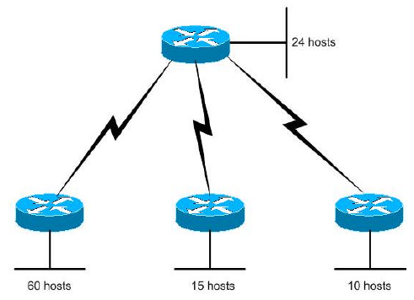

Gentle Reminder

Make sure to include the 3 WAN subnets for this topology.

